Qualitative Social Science Methods in Design

Participant Observation: What Genevieve Bell calls “deep hanging out” – observing people by taking part in their activities. It is the classic method of ethnographic study. This will be our first field site exercise. Be sure you write down what happened as soon as possible; writing is essential to field work.

Cultural probes: similar to the “reaction device” in our PDI-5 studio, but typically much less focused. For example, some Intel researchers use stack of cards with random images (flowers, dancers, kids playing, kitchen, etc.). Informants are asked to pick a card that they associate with their (computer, phone, etc – the object of investigation). Then explain your choice. Other groups have used postcards, craft materials, etc. Photo diaries, cognitive maps, and story-telling is sometimes included as part of this.

Photo diaries: For example, take a photo of your surroundings every time you use your (computer, phone, pencil, etc– the object of investigation). We will not use this directly, but I will provide photo documentation of the field experiences. You are welcome to bring a camera yourself, but be sure that you do not use names of students when posting to the web, and clear permission for photo use with professor Eglash (we will check with the teacher for any students whose parents did not sign the photo release form).

Cognitive mapping: eg give informants a map of where they live (house, town, etc) and ask them to mark up the map as to where: They would go to meet people, They would go to be alone, They liked to daydream, They would like to go but can't. Or: map out the “vibes” you get when moving around your area in terms of (safety, fun, seriousness, danger, etc.).

Story-telling exercises: these can be invented or real stories, based on experiences, evocative artifacts, etc.

Sensory exercises: Indirect use of imagery, smell, etc. See card example in “cultural probe” above. Another example: use a different color to color in these photos of various technologies in your home. Now explain the colors. This can be done with other senses as well, for example you can ask which shape reminds you of your relationship to your laptop: 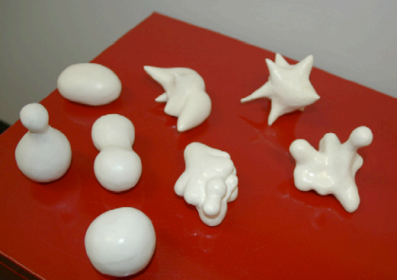

Reading:

http://www.gold.ac.uk/media/30gaver-etal.probes+uncertainty.interactions04.pdf

http://www.dourish.com/publications/2007/chi2007-probes.pdf

http://www.katherineinterface.com/SEIIJHCS.pdf

https://www.researchgate.net/publication/252627658_Opening_the_Cultural_Probes_Box_A_Critical_Reflection_and_Analysis_of_the_Cultural_Probes_Method

